**Table S1.** List of all assumptions and input parameters for assessment with the share table process model

| Scenario Category Name | Scenario Description | Storage System | Ambient Temperature  °C (°F) | Milk Initial Contamination (  CFU/mL) | Overnight Refrigeration Temperature °C (°F) | Bell Schedule and total lunch service length (min) |
| --- | --- | --- | --- | --- | --- | --- |
| Baseline | Milk cartons are placed at ambient temperature during lunch service | Ambient temperature | 22.1 (72) | 0.38 1.11 | 3.71 (39) | 2 lunch services with 1 break with a total time of 125 min |
| *Share Table Status Scenario* | | | | | | |
| No Share Table | No share table in the cafeteria system. If a student grabs a milk carton it can be consumed or wasted | Ambient temperature | 22.1 (72) | 0.38 1.11 | 3.71 (39) | 2 lunch services with 1 break with a total time of 125 min |
| *Storage System Scenario* | | | | | | |
| Ambient with Intermediate Refrigeration | Milk cartons are placed at an ambient temperature during lunch service and moved to refrigeration (3.71°C) during break | Ambient temperature and refrigeration | 22.1 (72) | 0.38 1.11 | 3.71 (39) | 2 lunch services with 1 break with a total time of 125 min |
| Cooler with Ice | Milk cartons are placed inside a portable cooler with a closed lid filled with ice | Cooler with Ice | 22.1 (72) | 0.38 1.11 | 3.71 (39) | 2 lunch services with 1 break with a total time of 125 min |
| Refrigerated Tray | Milk cartons are placed inside a metal steam table tray which was placed in overnight refrigeration the prior day | Refrigerated Tray | 22.1 (72) | 0.38 1.11 | 3.71 (39) | 2 lunch services with 1 break with a total time of 125 min |
| Tray with Ice | Milk cartons are placed inside a metal steam table tray filled with ice | Tray with Ice | 22.1 (72) | 0.38 1.11 | 3.71 (39) | 2 lunch services with 1 break with a total time of 125 min |
| Tray with Ice Packs | Milk cartons are placed inside a metal steam table tray lined with gel ice packs | Tray with Ice Packs | 22.1 (72) | 0.38 1.11 | 3.71 (39) | 2 lunch services with 1 break with a total time of 125 min |
| *Ambient Temperature Scenarios* | | | | | | |
| 18.3°C | Milk cartons are placed at ambient temperature during lunch service | Ambient temperature | 18.3 (65) | 0.38 1.11 | 3.71 (39) | 2 lunch services with 1 break with a total time of 125 min |
| 21.1°C | Milk cartons are placed at ambient temperature during lunch service | Ambient temperature | 21.1 (70) | 0.38 1.11 | 3.71 (39) | 2 lunch services with 1 break with a total time of 125 min |
| 23.8°C | Milk cartons are placed at ambient temperature during lunch service | Ambient temperature | 23.8 (75) | 0.38 1.11 | 3.71 (39) | 2 lunch services with 1 break with a total time of 125 min |
| *Initial Fixed Contamination Scenarios\** | | | | | | |
| Low | Milk cartons are placed at ambient temperature during lunch service | Ambient temperature | 22.1 (72) | -1.77 | 3.71 (39) | 2 lunch services with 1 break with a total time of 125 min |
| Medium | Milk cartons are placed at ambient temperature during lunch service | Ambient temperature | 22.1 (72) | 0.38 | 3.71 (39) | 2 lunch services with 1 break with a total time of 125 min |
| High | Milk cartons are placed at ambient temperature during lunch service | Ambient temperature | 22.1 (72) | 2.52 | 3.71 (39) | 2 lunch services with 1 break with a total time of 125 min |
| Very High | Milk cartons are placed at ambient temperature during lunch service | Ambient temperature | 22.1 (72) | 3.21 | 3.71 (39) | 2 lunch services with 1 break with a total time of 125 min |
| *Overnight Refrigeration Scenarios* | | | | | | |
| 2°C | Milk cartons are placed at ambient temperature during lunch service | Ambient temperature | 22.1 (72) | 0.38 1.11 | 2 (36) | 2 lunch services with 1 break with a total time of 125 min |
| 4°C | Milk cartons are placed at ambient temperature during lunch service | Ambient temperature | 22.1 (72) | 0.38 1.11 | 4 (39.2) | 2 lunch services with 1 break with a total time of 125 min |
| 7°C | Milk cartons are placed at ambient temperature during lunch service | Ambient temperature | 22.1 (72) | 0.38 1.11 | 7 (45) | 2 lunch services with 1 break with a total time of 125 min |
| *Bell Schedule Scenarios* | | | | | | |
| Very Short | Milk cartons are placed at ambient temperature during lunch service | Ambient temperature | 22.1 (72) | 0.38 1.11 | 3.71 (39) | 1 lunch service with 0 breaks with a total time of 40 min |
| Short | Milk cartons are placed at ambient temperature during lunch service | Ambient temperature | 22.1 (72) | 0.38 1.11 | 3.71 (39) | 2 lunch services with 1 break with a total time of 74 min |
| Medium | Milk cartons are placed at ambient temperature during lunch service | Ambient temperature | 22.1 (72) | 0.38 1.11 | 3.71 (39) | 3 lunch services with 2 breaks with a total time of 125 min |
| Long | Milk cartons are placed at ambient temperature during lunch service | Ambient temperature | 22.1 (72) | 0.38 1.11 | 3.71 (39) | 4 lunch services with 3 breaks with a total time of 221 min |
| Very Long | Milk cartons are placed at ambient temperature during lunch service | Ambient temperature | 22.1 (72) | 0.38 1.11 | 3.71 (39) | 5 lunch services with 4 breaks with a total time of 266 min |
| *Longer Bell Schedules with Reasonable Storage Systems* | | | | | | |
| Long with Tray with Ice | Milk cartons are placed at ambient temperature during lunch service | Tray with Ice | 22.1 (72) | 0.38 1.11 | 3.71 (39) | 4 lunch services with 3 breaks with a total time of 221 min |
| Long with Tray with Ice Packs | Milk cartons are placed at ambient temperature during lunch service | Tray with Ice Packs | 22.1 (72) | 0.38 1.11 | 3.71 (39) | 4 lunch services with 3 breaks with a total time of 221 min |
| Very Long with Tray with Ice | Milk cartons are placed at ambient temperature during lunch service | Tray with Ice | 22.1 (72) | 0.38 1.11 | 3.71 (39) | 5 lunch services with 4 breaks with a total time of 266 min |
| Very Long with Tray with Ice Packs | Milk cartons are placed at ambient temperature during lunch service | Tray with Ice Packs | 22.1 (72) | 0.38 1.11 | 3.71 (39) | 5 lunch services with 4 breaks with a total time of 266 min |

*For initial contamination scenarios variability was not considered and milk cartons had equal initial contamination.

**Figure S4.** Training data sets observed vs predicted temperature profiles. The observed milk internal temperatures for an hour from 3 repetitions were used to calculate the heat transfer coefficients for the different storage systems and refrigeration. Each repetition uses its heat transfer coefficient to simulate the predicted temperature profile. The root mean squared error was used as a measure of precision for the predicted temperature profiles and bias as a measure of accuracy. Lower milk peaks after an hour means higher efficacy to control milk temperature.

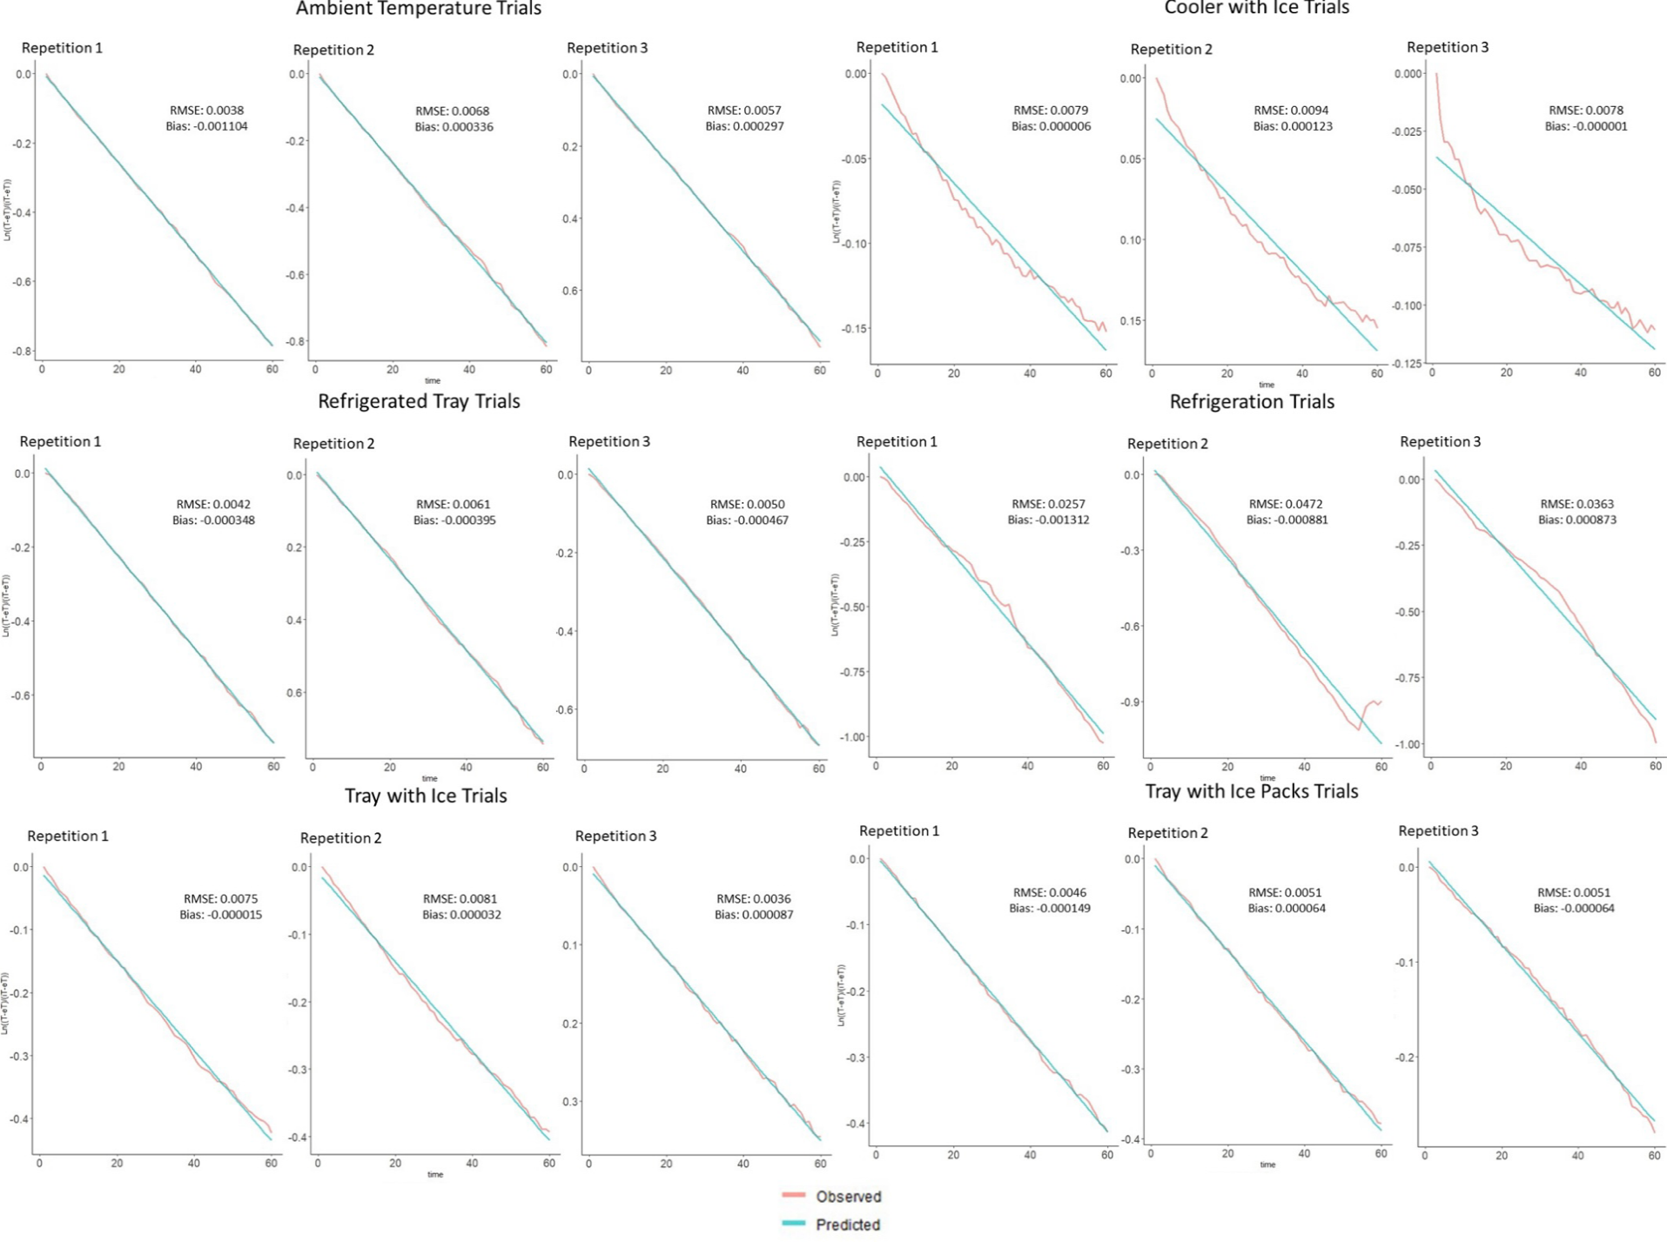**Figure S5.** Semi-log plots for all training data sets. All follow a log-linear trend except for the cooler with ice.

**Figure S6.** Temperature profiles used for the different scenarios. The maximum temperature for each milk is shown. Lower milk temperatures means that the storage system, ambient or overnight refrigeration temperature or bell schedule more successfully controlled the milk’s internal temperature. Room temperature could be either ambient temperature during the lunch service or refrigeration temperature during the overnight refrigeration storage.